WELCOME TO WORSHIP!

7th Sunday after Epiphany
February 24, 2019 • 10:00 AM
~~~~~
Church of Our Saviour, Lutheran
The Reverend Marc Herbst, Pastor
Judith Feuss, Music Director/Organist
Church of Our Saviour, Lutheran
A Congregation of the Evangelical Lutheran Church in America
1901 Northern Boulevard
Manhasset, NY 11030
516-627-2430 • 516-627-3755 fax
www.manhassetlutheran.org • info@manhassetlutheran.org
Office Hours: Mondays – Fridays, 9:00 AM – 1:00 PM or by appointment

The Reverend Marc Herbst, Pastor 631-873-6985 (cellular) pastor@manhassetlutheran.org
Dorothy Maus, Church Administrator office@manhassetlutheran.org
Judith Feuss, Music Director musicdirector@manhassetlutheran.org
Bobby Stainkamp, Youth Director youthdirector@manhassetlutheran.org

WELCOME to the CHURCH OF OUR SAVIOUR, LUTHERAN (COSL)! We are pleased to have you join us for worship today, and we hope that your experience is spiritually enriching and meaningful.

IF YOU ARE NEW to COSL, here are some things you might like to know:

- Who we are. COSL is a congregation of the family of God that welcomes all people without discrimination or prejudice, seeking to strengthen one another with Word and Sacraments, prayer and example. Our mission is to:
  - Share the Gospel of Jesus Christ and his love with all people.
  - Reach out to our community with friendship and witness.
  - Bring hope and healing to those who are in need, both at home and abroad.
  - Offer opportunities for worship, learning, fellowship and service.
  - Encourage all members to discover, develop and share their God-given talents.
- Children are always welcome to join us for worship. They are encouraged to come forward during Children’s Messages and participate. Also, please note that there are Activity Bags (containing books, coloring and other materials inside) available for children preschool to Age 6, in the narthex (entrance hall).
- Childcare is provided for interested families during worship. Ms. Anna Gordy, a mother of four and grandmother of nine (and counting!), has vast experience in child care, including 15 years at a local Parish Resource Center. This ministry is provided in the Nursery School Room, located on the lower level.
- Sunday School is available for children ages 4 through 12, is offered September through June. The program begins during the 10AM worship with an opening Children’s Message among the entire congregation, and then the students depart to learn beloved Bible stories, Lutheran identity and the love of Jesus. They return before the conclusion of worship to participate in the dismissal. On designated Youth Sundays the students may remain with the entire congregation and participate in a meaningful way throughout the liturgy.
- Coffee and refreshments are generally served following worship in the Parlor, located on the lower level accessible from the narthex (entrance hall). Please join us!
- Restrooms are located on the lower level along the main hallway. A changing table is available in another restroom located off of the fellowship hall.
- Worship Assistance and Emergency Needs. First aid kits and a defibrillator are readily available. Please see an usher if assistance is needed, or if you have any other concerns or questions.
- Pastoral Care. We minister to the spiritual, emotional and physical needs of all God’s children. Confidentiality is respected. For pastoral care please feel free to contact Pastor Marc Herbst (see contact info above) or one of our agencies: (counseling) Lutheran Counseling Center, 132 Jefferson Ave., Mineola, 800-317-1173 or 516-741-0994 or (food and essentials) New LIFE Center, Long Island, 311 Uniondale Ave., Uniondale, 516-483-3240.
7th Sunday after Epiphany • February 24, 2019 at 10:00 AM
Evangelical Lutheran Worship (ELW) – Holy Communion Setting Four
The Reverend Marc Herbst, Presiding Minister

Michael Wustrow, Guest Organist

PRELUDE Michael Wustow, Guest Organist

Gathering - The Holy Spirit calls us together as the people of God.

children’s message

CHILDREN’S dismissal: This Little Light of Mine (ELW Hymn 677) Verse 1

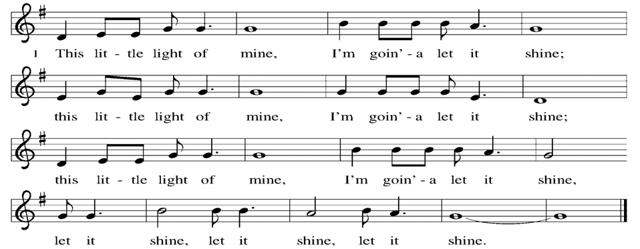

CONFESSION AND FORGIVENESS

The assembly stands. All may make the sign of the cross, the sign marked at baptism, as the presiding minister begins.

Presider: Blessed be the holy Trinity, ☩ one God, who creates us and forms us, who redeems us and calls us, who unites us and sends us.
All: Amen.

Presider: Gathered in God’s presence, let us confess our sin.

Silence is kept for reflection.

Presider: Mighty and loving God,
All: we confess that we are captive to sin and cannot free ourselves. We seek our own way. We divide the body of Christ. In your mercy, cleanse us and heal us. Let the words of our mouths, the thoughts of our hearts, and everything that we do be filled with faith, hope, and love.
Amen.

Presider: Hear the voice of Jesus: “The Spirit of the Lord is upon me to proclaim release to the captives.” In the name of ☩ Jesus Christ, I proclaim to you that your sins are forgiven and you are released. The joy of the Lord is your strength, and the gifts of the Holy Spirit are yours forever.
All: Amen.

entrance Hymn: How Firm a Foundation (ELW Hymn 796)
Greeting

During this time, the presiding minister and the assembly greet each other.

Presider: The grace of our Lord Jesus Christ, the love of God, and the communion of the Holy Spirit be with you all.
All: And also with you.

canticle of praise
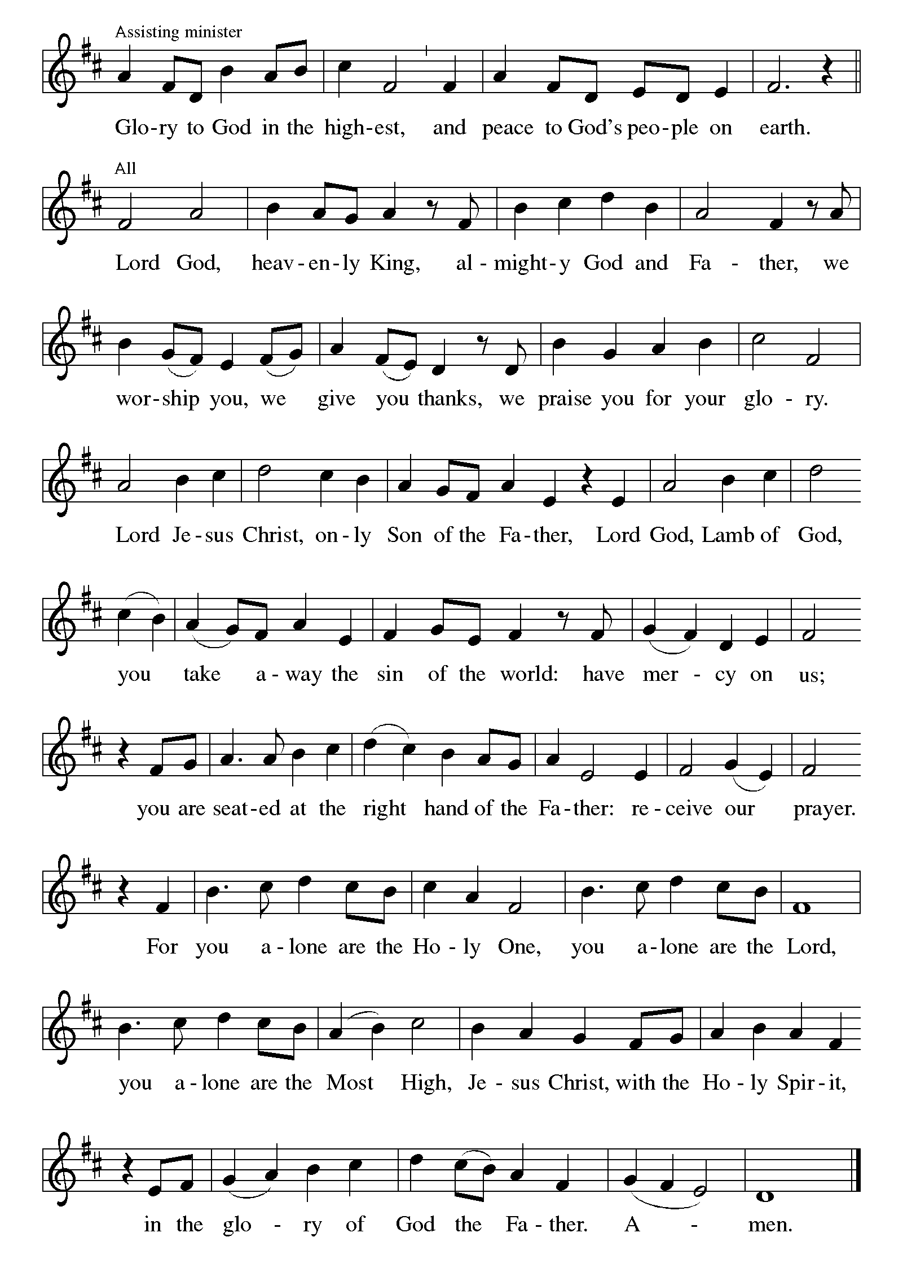

Prayer of the Day

Presider: The Lord be with you.
All: And also with you.

Presider: Let us pray.
O Lord Jesus, make us instruments of your peace, that where there is hatred, we may sow love, where there is injury, pardon, and where there is despair, hope. Grant, O divine master, that we may seek to console, to understand, and to love in your name, for you live and reign with the Father and the Holy Spirit, one God, now and forever.
All: Amen.

The assembly is seated.

Word - God speaks to us in scripture reading, preaching, and song.

First Reading: Genesis 45:3-11, 15

Many years after being sold into slavery by his jealous brothers, Joseph reveals himself to them. Now the second-in-command in Egypt, Joseph reassures his brothers that God has used their evil intentions for good, to preserve life during a devastating famine, and Joseph forgives them.

Lector: A reading from the Book of Genesis:

Lector: ³Joseph said to his brothers, “I am Joseph. Is my father still alive?” But his brothers could not answer him, so dismayed were they at his presence.
⁴Then Joseph said to his brothers, “Come closer to me.” And they came closer. He said, “I am your brother, Joseph, whom you sold into Egypt. ⁵And now do not be distressed, or angry with yourselves, because you sold me here; for God sent me before you to preserve life. ⁶For the famine has been in the land these two years; and there are five more years in which there will be neither plowing nor harvest. ⁷God sent me before you to preserve for you a remnant on earth, and to keep alive for you many survivors. ⁸So it was not you who sent me here, but God; he has made me a father to Pharaoh, and lord of all his house and ruler over all the land of Egypt. ⁹Hurry and go up to my father and say to him, ‘Thus says your son Joseph, God has made me lord of all Egypt; come down to me, do not delay. ¹⁰You shall settle in the land of Goshen, and you shall be near me, you and your children and your children’s children, as well as your flocks, your herds, and all that you have. ¹¹I will provide for you there—since there are five more years of famine to come—so that you and your household, and all that you have, will not come to poverty.’ ” ¹⁵And he kissed all his brothers and wept upon them; and after that his brothers talked with him.

Lector: The word of the Lord.
All: Thanks be to God.

Psalm: Psalm 37:1-11, 39-40

Assistant: The Psalm for the day is spoken responsively.

Assistant: ¹Do not be provoked by evildoers;
do not be jealous of those who do wrong.
All: ²For they shall soon wither like the grass,
and like the green grass fade away.
Assistant: ³Put your trust in the Lord and do good;
dwell in the land and find safe pasture.
All: ⁴Take delight in the Lord,
who shall give you your heart’s desire.
Assistant: ⁵Commit your way to the Lord; put your trust in the Lord,
and see what God will do.
All: ⁶The Lord will make your vindication as clear as the light
and the justice of your case like the noonday sun.
Assistant: ⁷Be still before the Lord and wait patiently.
Do not be provoked by the one who prospers,
the one who succeeds in evil schemes.
All: ⁸Refrain from anger, leave rage alone;
do not be provoked; it leads only to evil.
Assistant: ⁹For evildoers shall be cut off,
but those who hope in the Lord shall possess the land.
All: ¹⁰In a little while the wicked shall be no more;
even if you search out their place, they will not be there.
Assistant: ¹¹But the lowly shall possess the land;
they will delight in abundance of peace.
All: ³⁹But the deliverance of the righteous comes from you, O Lord;
you are their stronghold in time of trouble.
Assistant: ⁴⁰You, O Lord, will help them and rescue them;
you will rescue them from the wicked and deliver them,
because in you they seek refuge.
second Reading: 1 Corinthians 15:35-38, 42-50

In the Apostles Creed, we speak of the “resurrection of the body and the life everlasting.” Using the metaphor of a planted seed and the story of Adam, Paul preaches passionately about the mystery of following Christ’s perfect life into eternity.

Lector: A reading from Saint Paul’s First Letter to the Corinthians:

Lector: ³⁵But someone will ask, “How are the dead raised? With what kind of body do they come?” ³⁶Fool! What you sow does not come to life unless it dies. ³⁷And as for what you sow, you do not sow the body that is to be, but a bare seed, perhaps of wheat or of some other grain. ³⁸But God gives it a body as he has chosen, and to each kind of seed its own body.
⁴²So it is with the resurrection of the dead. What is sown is perishable, what is raised is imperishable. ⁴³It is sown in dishonor, it is raised in glory. It is sown in weakness, it is raised in power. ⁴⁴It is sown a physical body, it is raised a spiritual body. If there is a physical body, there is also a spiritual body. ⁴⁵Thus it is written, “The first man, Adam, became a living being”; the last Adam became a life-giving spirit. ⁴⁶But it is not the spiritual that is first, but the physical, and then the spiritual. ⁴⁷The first man was from the earth, a man of dust; the second man is from heaven. ⁴⁸As was the man of dust, so are those who are of the dust; and as is the man of heaven, so are those who are of heaven. ⁴⁹Just as we have borne the image of the man of dust, we will also bear the image of the man of heaven.
⁵⁰What I am saying, brothers and sisters, is this: flesh and blood cannot inherit the kingdom of God, nor does the perishable inherit the imperishable.

Lector: The word of the Lord. All: Thanks be to God.

The assembly stands to welcome the gospel.

Gospel acclamation

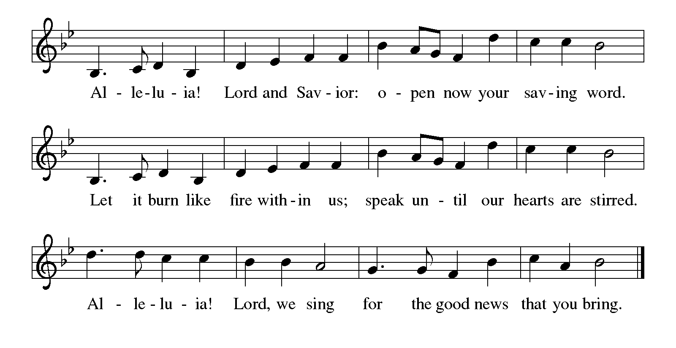

Gospel: Luke 6:27-38

Jesus continues to address a crowd of his disciples. He invites his followers to shower radical love, blessing, forgiveness, generosity, and trust even to enemies and outsiders. Living in harmony with God’s intent brings the reward of overflowing blessing.

Presider: The holy gospel according to Saint Luke:
All: Glory to you, O Lord.

Presider: [Jesus said:] ²⁷“But I say to you that listen, Love your enemies, do good to those who hate you, ²⁸bless those who curse you, pray for those who abuse you. ²⁹If anyone strikes you on the cheek, offer the other also; and from anyone who takes away your coat do not withhold even your shirt. ³⁰Give to everyone who begs from you; and if anyone takes away your goods, do not ask for them again. ³¹Do to others as you would have them do to you.
³²“If you love those who love you, what credit is that to you? For even sinners love those who love them. ³³If you do good to those who do good to you, what credit is that to you? For even sinners do the same. ³⁴If you lend to those from whom you hope to receive, what credit is that to you? Even sinners lend to sinners, to receive as much again. ³⁵But love your enemies, do good, and lend, expecting nothing in return. Your reward will be great, and you will be children of the Most High; for he is kind to the ungrateful and the wicked. ³⁶Be merciful, just as your Father is merciful.
³⁷“Do not judge, and you will not be judged; do not condemn, and you will not be condemned. Forgive, and you will be forgiven; ³⁸give, and it will be given to you. A good measure, pressed down, shaken together, running over, will be put into your lap; for the measure you give will be the measure you get back.”

Presider: The gospel of the Lord.
All: Praise to you, O Christ.

The assembly is seated.

Sermon

The assembly stands.

HYMN of the day: Love Divine, All Loves Excelling (ELW Hymn 631)

Creed

Presider: Let us confess our faith in the words of the Apostles’ Creed:
All: I believe in God, the Father almighty,
creator of heaven and earth.

All: I believe in Jesus Christ, God’s only Son, our Lord,
who was conceived by the Holy Spirit,
born of the virgin Mary,
suffered under Pontius Pilate,
was crucified, died, and was buried;
he descended to the dead.
On the third day he rose again;
he ascended into heaven,
he is seated at the right hand of the Father,
and he will come to judge the living and the dead.

All: I believe in the Holy Spirit,
the holy catholic church,
the communion of saints,
the forgiveness of sins,
the resurrection of the body,
and the life everlasting.
Amen.

Prayers of Intercession

Assistant: United as one body in Christ, let us pray for the church, the world, and all those in need.

A brief silence.

Assistant: We pray for the church. Fill us with a spirit of generosity and care. Lead us to forgive as we have been forgiven. Show us new ways to be helpful to others. Lord, in your mercy,
All: hear our prayer.

Assistant: For the earth. Grant seasonable weather for the planting and harvesting of crops. Protect farms, orchards, and gardens from damage. Bless those who till fields, those who care for livestock, and all who provide food. Lord, in your mercy,
All: hear our prayer.

Assistant: For those in need. For those who lack adequate food, shelter, or access to medical care; for those unable to find gainful employment. Heal the sick, and comfort the grieving especially Otto, Hilda, Helen, Joseph, Jeanne, Irma, Christa, Mary, Belle, Jean, Angele, Joyce, Craig, Raymond, Florence, Donna, Christian, Virginia, Elizabeth, Horton, John and Elizabeth. Lord, in your mercy,
All: hear our prayer.

Assistant: For this assembly and those unable to join us. Inspire us to be good stewards of the resources you have entrusted to us, especially members of the Cueto, Herbert, McDermott, Phillips, and Taukus Families. Teach us to give freely of ourselves and to offer our lives in service. Lord, in your mercy,
All: hear our prayer.

Assistant: For those who are observing special occasions. Increase the joys of celebration and bless the observance of birthdays, especially those of Grace, Flora, Kate, Sal, Sarah and Olivia. Lord, in your mercy,
All: hear our prayer.

Assistant: With thanksgiving, we remember those who have died. Even in the midst of death, give us faith to trust your promise of everlasting life. Lord, in your mercy,
All: hear our prayer.

Presider: Receive our prayers and fill us with the radiance of your love; through Jesus Christ our Lord.
All: Amen.

Peace

Presider: The peace of Christ be with you always.
All: And also with you.

The people may greet one another with a sign of Christ’s peace, and may say, “Peace be with you,” or similar words.

The assembly is seated.

Meal - God feeds us with the presence of Jesus Christ.

Offering

An offering is gathered for the mission of the church, including the care of those in need. During this time, the table is set. The Offertory Anthem accompanies the gathering of the offering.

Offertory anthem: Ave Verum (W.A. Mozart)

The assembly stands. Bread, wine, money and other gifts may be brought forward.

PRESENTATION OF GIFTS and OFFERING SONG:
Let the Vineyards be Fruitful (ELW Hymn 184)
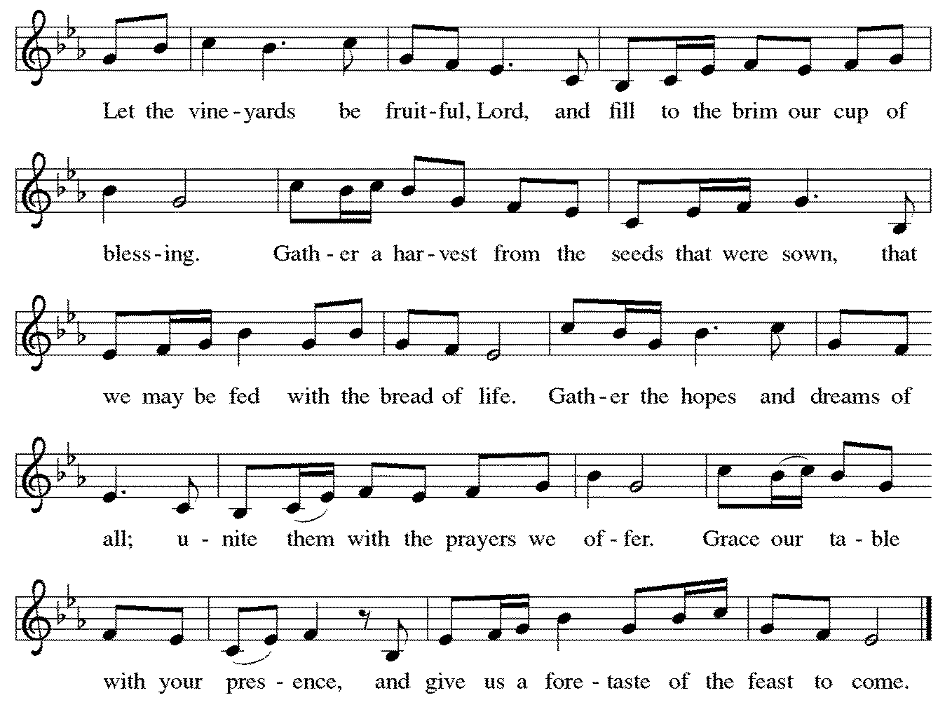

Offering Prayer

After the table is set, the assisting minister leads the following prayer.

Assistant: Let us pray.
God of all creation, all you have made is good, and your love endures forever. You bring forth bread from the earth and fruit from the vine. Nourish us with these gifts, that we might be for the world signs of your gracious presence in Jesus Christ, our Savior and Lord.
All: Amen.
Dialogue

Presider: The Lord be with you.
All: And also with you.

Presider: Lift up your hearts.
All: We lift them to the Lord.

Presider: Let us give thanks to the Lord our God.
All: It is right to give our thanks and praise.

Presider: It is indeed right, our duty and our joy, that we should at all times and in all places give thanks and praise to you, almighty and merciful God,
through our Savior Jesus Christ. By the leading of a star he was shown forth to all nations; in the waters of the Jordan you proclaimed him your beloved Son; and in the miracle of water turned to wine he revealed your glory. And so, with all the choirs of angels, with the church on earth and the hosts of heaven, we praise your name and join their unending hymn:
SANCtus: Holy, Holy, Holy

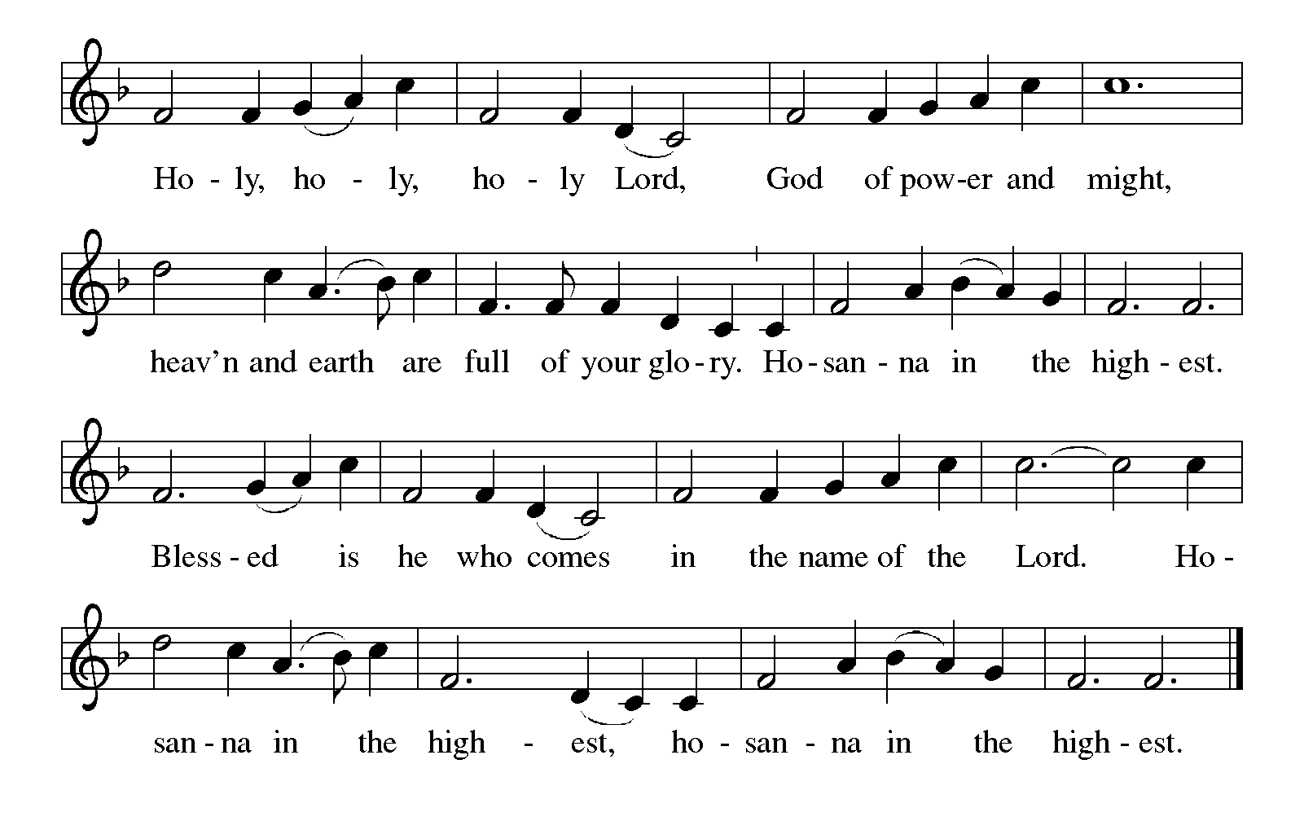
Thanksgiving at the Table

Presider: Holy One, the beginning and the end, the giver of life:
Blessed are you for the birth of creation.
Blessed are you in the darkness and in the light.
Blessed are you for your promise to your people.
Blessed are you in the prophets’ hopes and dreams.
Blessed are you for Mary’s openness to your will.
Blessed are you for your Son Jesus, the Word made flesh.

Presider: In the night in which he was betrayed, our Lord Jesus took bread, and gave thanks; broke it, and gave it to his disciples, saying: Take and eat; this is my body, given for you. Do this for the remembrance of me.

Presider: Again, after supper, he took the cup, gave thanks, and gave it for all to drink, saying: This cup is the new covenant in my blood, shed for you and for all people for the forgiveness of sin. Do this for the remembrance of me.

Presider: Let us proclaim the mystery of faith:
All: Christ has died. Christ is risen. Christ will come again.

Presider: With this bread and cup we remember your Word dwelling among us,
full of grace and truth. We remember our new birth in his death and resurrection. We look with hope for his coming.
All: Come, Lord Jesus.

Presider: Holy God, we long for your Spirit. Come among us. Bless this meal.
May your Word take flesh in us. Awaken your people. Fill us with your light. Bring the gift of peace on earth.
All: Come, Holy Spirit.

Presider: All praise and glory are yours, Holy One of Israel, Word of God incarnate, Power of the Most High, one God, now and forever.
All: Amen.

Lord's Prayer

Presider: Lord, remember us in your kingdom, and teach us to pray:
All: Our Father, who art in heaven,
hallowed be thy name,
thy kingdom come,
thy will be done,
on earth as it is in heaven.
Give us this day our daily bread;
and forgive us our trespasses,
as we forgive those
who trespass against us;
and lead us not into temptation,
but deliver us from evil.
For thine is the kingdom,
and the power, and the glory,
forever and ever.
Amen.

Invitation to Communion

Presider: Come to the table. Feast on God’s abundant life for you.

The assembly is seated. The bread may be broken for the communion.

Communion

We welcome all baptized believers, regardless of faith tradition, to celebrate Holy Communion at the Lord’s Table. Ushers will help guide all for the distribution of Holy Communion. Unless instructed otherwise, worshipers will approach the altar from the center aisle and, if able, kneel at the Altar Rail. The presiding minister will distribute the consecrated bread, or hosts. Assisting ministers will offer individual cups of consecrated red wine and white grape juice. Should anyone have dietary concerns, gluten-free consecrated hosts are readily available upon request to the presiding minister. If you do not wish to receive Holy Communion, you are still invited to come to the Lord’s Table to receive a blessing; kindly cross your arms as a method to advise the presiding minister of your desire to be blessed. When giving the bread and cup, the communion ministers say, “The body of Christ, given for you,” and “The blood of Christ, shed for you,” and each person may respond “Amen.” Following receipt of Holy Communion, the acolyte will collect the empty cups, and the communed worshipers are invited to return to their places via the side aisles.

Communion hymn
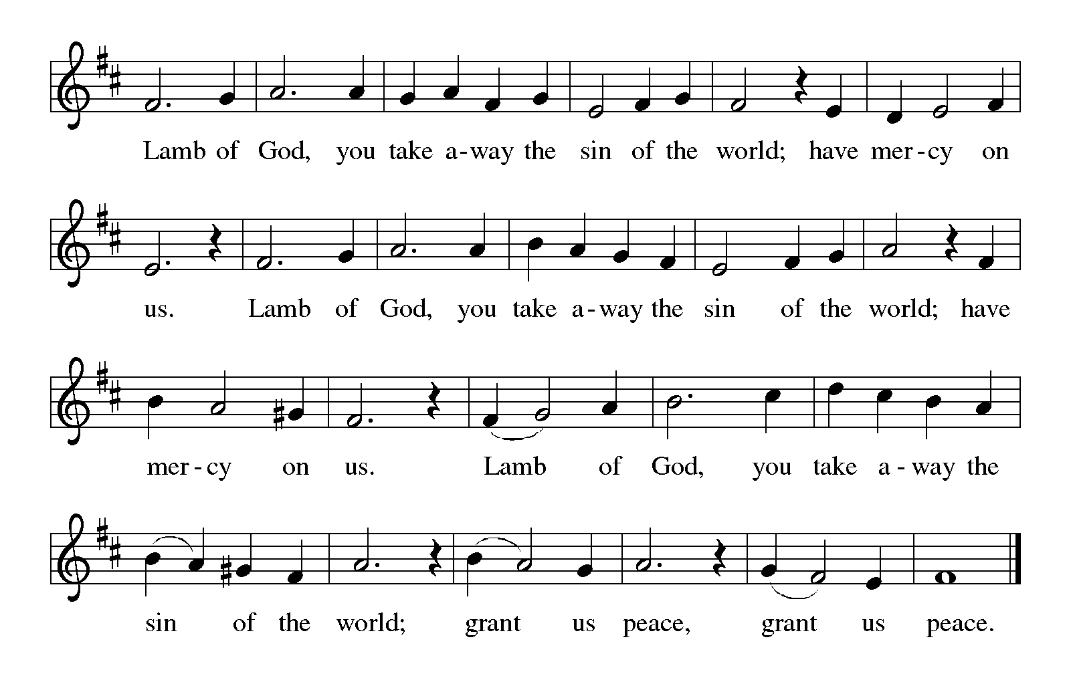
COMMUNION SONG: Where Charity and Love Prevail (ELW Hymn 359)
Just as I am, without One Plea (ELW Hymn 592)

After all have returned to their places, the assembly stands.

table blessing

Presider: The body and blood of our Lord Jesus Christ strengthen you and keep you in his grace.
All: Amen.
POST-COMMUNION CANTICLE:
Thankful Hearts and Voices Raise (ELW Hymn 204)
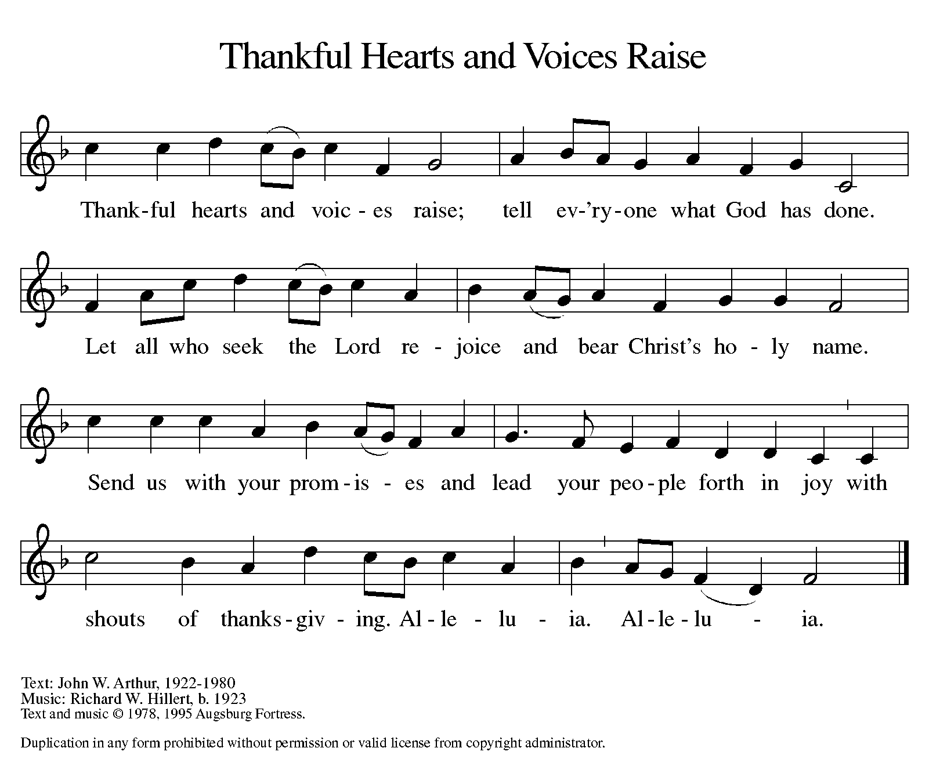

Prayer after Communion

Assistant: Let us pray.
We thank you, O God, that you have fed us at your banqueting table with bread and wine beyond compare, the very life of Christ for us. Send your Spirit with us now, that we may set the captive free, use your gifts to build one another up, and in everything reflect your glory revealed in Jesus Christ, our Savior and Lord.
All: Amen.

The assembly is seated.

Sending - God blesses us and sends us in mission to the world.

Announcements

Brief announcements may be made, especially those related to the assembly’s participation in God’s mission in the world.

The assembly stands.

BENEDICTION

Presider: The God of glory dwell in you richly, name you beloved, and shine brightly on your path; and the blessing of almighty God, the Father, the ☩ Son, and the Holy Spirit, be upon you and remain with you always.
All: Amen.

Sending hymn: O Christ, Our Hope (ELW Hymn 604) verses 1-3

Dismissal

Assistant: Go in peace. Serve the Lord.
All: Thanks be to God.

POSTLUDE

Copyright © 2019 Augsburg Fortress. All rights reserved. Reprinted by permission under Augsburg Fortress Liturgies Annual License #SAS000352.
New Revised Standard Version Bible, Copyright © 1989, Division of Christian Education of the National Council of the Churches of Christ in the United States of America. Used by permission. All rights reserved.
Revised Common Lectionary, Copyright © 1992 Consultation on Common Texts, admin Augsburg Fortress. Used by permission.

The Altar flower arrangement is from the Meredith family
in honor of Flora’s 15th birthday.

Serving this Sunday, February 24th
Ministers: People of the Church of Our Saviour, Lutheran
Acolyte/Crucifer: Flora Meredith
Assisting Minister: Liana Bordonaro
Lector: Adrienne Nagy
Ushers: Dan Nigro & Alex Rekow
Altar guild: Adrienne Nagy & Janice Pupelis
Recorder: Kathy McNally
Coffee Hour: Sieglinde Lubbers

Serving next Sunday, March 3rd
Ministers: People of the Church of Our Saviour, Lutheran
Acolyte/Crucifer: Sabrina Bordonaro
Assisting Minister: Kathy McNally
Lector: Jeanine Levitan
Ushers: Winston Baker & Jim Meredith
Altar guild: Norma Carrasco & Sieglinde Lubbers
Recorder: Katie Miller
Coffee Hour: Open

THIS WEEK AT THE CHURCH OF OUR SAVIOUR, LUTHERAN (COSL)

Today, Sunday, February 24th
10:00AM—Worship with Holy Communion, Sunday school, Childcare
Tuesday, February 26th
10:00AM – Ruth Circle crafts/Knitwits
1:00PM – Stammtisch meeting
7:30PM – Council meeting

UPCOMING CHURCH EVENTS

SUNDAY SCHOOL: Class meets most Sundays @ 10:15am from September through June.

KNITWITS/RUTH CIRCLE CRAFTS: This group meets most Tuesdays at 10am.

RUTH CIRCLE BABY SHOWER: This annual event will take place on Sunday, March 3rd following worship @ 11:30am. Snow date is Sunday, March 10th @ 11:30am.

ASH WEDNESDAY SERVICES: Services will be held at noon and 7pm on Wednesday, March 6th.

UPCOMING CHURCH EVENTS (cont’d)

CONFIRMATION CLASSES: Confirmation classes in March will meet on the following Wednesdays @ 6:15pm: March 6th, 13th, 20th and 27th. A detailed list of all classes was issued to all Confirmation families.

RESOURCE COMMITTEE MEETING: This meeting will take place following worship on Sunday, March 10th @ 11:45am.

STAMMTISCH MEETINGS: This group’s March meetings take place on Tuesday, March 12th @ 1pm and Tuesday, March 26th @ 1pm.

COUNCIL MEETING: The Council will hold its March meeting on Tuesday, March 19th @ 7:30pm.

FIESTA NIGHT: This fundraiser will be taking place on Saturday, March 30th @ 6pm. See flyers in parlor and bulletin board for more information.

2019 ALTAR FLOWER CHART

A 2019 altar flower chart is up on the bulletin board to sign up for your Sunday altar flowers. There are still plenty of dates available. Cost is $25.

PRAYERS OF COMFORT AND HEALING
(Unless a renewed request is received, prayer intercessions for individuals will be listed for three consecutive weeks.)

ASSISTED CARE/HOMEBOUND: Otto Ackerman, Hilda Bormann, Helen Carstens (mother of Jeff Carstens), Joseph Cobb (father of Carol Herbst), Jeanne Geib, Irma Grunewald, Christa Horn, Mary Kavanagh, Belle Lewis, Jean Millington (mother of Debbie Capilupi), Angele Moomjy and Joyce Morin.

HOSPITALIZATION/ILLNESS/MEDICAL CARE: Craig Anderson (father of Keri Anderson Reda), Raymond Bordonaro (father in law of Kristine Bordonaro), Florence Buzzitta, Donna Houman (friend of Elise Cueto), Virginia Marshall, Christian Miller (son of Katie Miller), Elizabeth Nagy, Horton Schwartz (brother of Jeanine Levitan), John Stallard (friend of Denise Johnson) and Elizabeth (Betty) Kelly Volker (mother of Eugenia Kelly Viner)

PRAYERS OF THANKSGIVING—2/24-3/3
BIRTHDAYS: Grace Hanford – 2/26, Flora Meredith and Kate Taukus – 2/28, Sal Furciato – 2/29, Sarah Weigand – 3/1, Olivia Rich – 3/2

FINANCIALS
JANUARY YTD

Income: $20,307
Expenses: $30,337
Deficit: $(10,030)

2019 SACRIFICE AND SERVE LENTEN SERIES

Each week during our worship in the Lenten Season a special guest will exemplify the Lenten call to “Sacrifice and Serve.” We will learn of those caring for others, and lift them up in prayer for their service, and be inspired to consider personal opportunities to serve God in similar means of thanksgiving.

March 10th: Hunger & Poverty
Jean Kelly, The Interfaith Nutrition Network
March 17th: Emergency Response
Neela Mukherjee Lockel, American Red Cross
March 24th: Labor/Workforce
John Durso, Long Island Federation of Labor
March 31st: Public Service
Honorable Thomas Suozzi, U.S. Congressman
April 7th: Addictions
Drew Scott, Opioid Addiction Task Forces

MIDWEEK LENTEN WORSHIP: Each week, on Wednesday evenings, beginning at 7:00 PM, you are invited to join us for a brief, approximate 30-minute, worship service.

March 13th: Luke 4:1-11
March 20th Luke 13:31-35
March 27th: Luke 13:1-9
April 3rd: Luke 15:1-3, 11b-32
April 10th: John 12 1-8
April 17th: Seder (Passover 4/19-27)

