WELCOME TO WORSHIP!

6th Sunday after Epiphany
February 17, 2019 • 10:00 AM
~~~~~
Church of Our Saviour, Lutheran
The Reverend Marc Herbst, Pastor
Judith Feuss, Music Director/Organist
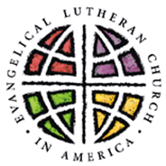
Church of Our Saviour, Lutheran
A Congregation of the Evangelical Lutheran Church in America
1901 Northern Boulevard
Manhasset, NY 11030
516-627-2430 • 516-627-3755 fax
www.manhassetlutheran.org • info@manhassetlutheran.org
Office Hours: Mondays – Fridays, 9:00 AM – 1:00 PM or by appointment

The Reverend Marc Herbst, Pastor 631-873-6985 (cellular) pastor@manhassetlutheran.org
Dorothy Maus, Church Administrator office@manhassetlutheran.org
Judith Feuss, Music Director musicdirector@manhassetlutheran.org
Bobby Stainkamp, Youth Director youthdirector@manhassetlutheran.org

WELCOME to the CHURCH OF OUR SAVIOUR, LUTHERAN (COSL)! We are pleased to have you join us for worship today, and we hope that your experience is spiritually enriching and meaningful.

IF YOU ARE NEW to COSL, here are some things you might like to know:

- Who we are. COSL is a congregation of the family of God that welcomes all people without discrimination or prejudice, seeking to strengthen one another with Word and Sacraments, prayer and example. Our mission is to:
  - Share the Gospel of Jesus Christ and his love with all people.
  - Reach out to our community with friendship and witness.
  - Bring hope and healing to those who are in need, both at home and abroad.
  - Offer opportunities for worship, learning, fellowship and service.
  - Encourage all members to discover, develop and share their God-given talents.
- Children are always welcome to join us for worship. They are encouraged to come forward during Children’s Messages and participate. Also, please note that there are Activity Bags (containing books, coloring and other materials inside) available for children preschool to Age 6, in the narthex (entrance hall).
- Childcare is provided for interested families during worship. Ms. Anna Gordy, a mother of four and grandmother of nine (and counting!), has vast experience in child care, including 15 years at a local Parish Resource Center. This ministry is provided in the Nursery School Room, located on the lower level.
- Sunday School is available for children ages 4 through 12, is offered September through June. The program begins during the 10AM worship with an opening Children’s Message among the entire congregation, and then the students depart to learn beloved Bible stories, Lutheran identity and the love of Jesus. They return before the conclusion of worship to participate in the dismissal. On designated Youth Sundays the students may remain with the entire congregation and participate in a meaningful way throughout the liturgy.
- Coffee and refreshments are generally served following worship in the Parlor, located on the lower level accessible from the narthex (entrance hall). Please join us!
- Restrooms are located on the lower level along the main hallway. A changing table is available in another restroom located off of the fellowship hall.
- Worship Assistance and Emergency Needs. First aid kits and a defibrillator are readily available. Please see an usher if assistance is needed, or if you have any other concerns or questions.
- Pastoral Care. We minister to the spiritual, emotional and physical needs of all God’s children. Confidentiality is respected. For pastoral care please feel free to contact Pastor Marc Herbst (see contact info above) or one of our agencies: (counseling) Lutheran Counseling Center, 132 Jefferson Ave., Mineola, 800-317-1173 or 516-741-0994 or (food and essentials) New LIFE Center, Long Island, 311 Uniondale Ave., Uniondale, 516-483-3240.
6th Sunday after Epiphany • February 17, 2019 at 10:00 AM
Evangelical Lutheran Worship (ELW) – Holy Communion Setting Four
The Reverend Marc Herbst, Presiding Minister

PRELUDE: Comfort, Comfort Ye My People (P. Manz)

Gathering - The Holy Spirit calls us together as the people of God.

children’s message

CHILDREN’S dismissal: This Little Light of Mine (ELW Hymn 677) Verse 1

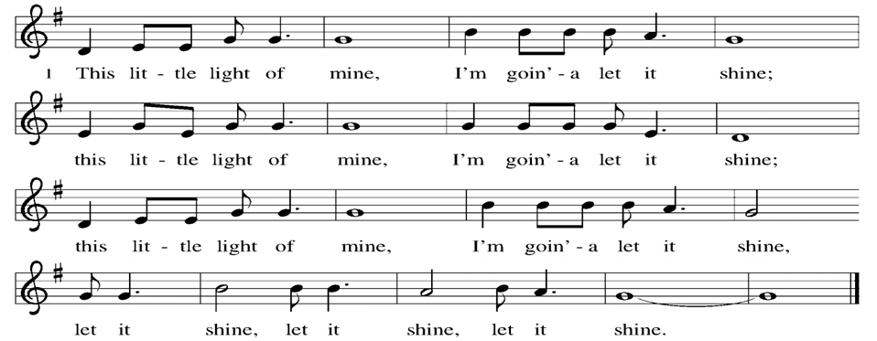

CONFESSION AND FORGIVENESS

The assembly stands. All may make the sign of the cross, the sign marked at baptism, as the presiding minister begins.

Presider: Blessed be the holy Trinity, ☩ one God, who creates us and forms us, who redeems us and calls us, who unites us and sends us.
All: Amen.

Presider: Gathered in God’s presence, let us confess our sin.

Silence is kept for reflection.

Presider: Mighty and loving God,
All: we confess that we are captive to sin and cannot free ourselves. We seek our own way. We divide the body of Christ. In your mercy, cleanse us and heal us. Let the words of our mouths, the thoughts of our hearts, and everything that we do be filled with faith, hope, and love.
Amen.

Presider: Hear the voice of Jesus: “The Spirit of the Lord is upon me to proclaim release to the captives.” In the name of ☩ Jesus Christ, I proclaim to you that your sins are forgiven and you are released. The joy of the Lord is your strength, and the gifts of the Holy Spirit are yours forever.
All: Amen.

entrance Hymn: We Know that Christ is Raised (ELW Hymn 449)
Greeting

During this time, the presiding minister and the assembly greet each other.

Presider: The grace of our Lord Jesus Christ, the love of God, and the communion of the Holy Spirit be with you all.
All: And also with you.

canticle of praise
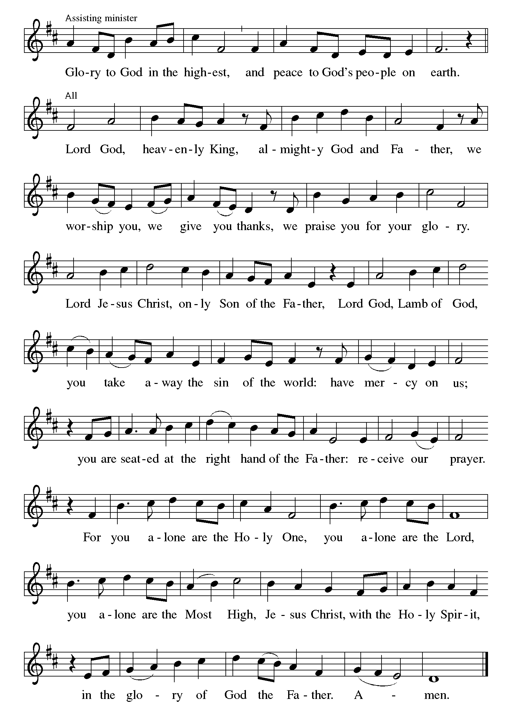

Prayer of the Day

Presider: The Lord be with you.
All: And also with you.

Presider: Let us pray.
Living God, in Christ you make all things new. Transform the poverty of our nature by the riches of your grace, and in the renewal of our lives make known your glory, through Jesus Christ, our Savior and Lord.
All: Amen.

The assembly is seated.

Word - God speaks to us in scripture reading, preaching, and song.

First Reading: Jeremiah 17:5-10

These verses compose a poem that is part of a larger collection of wisdom sayings (17:5-11) that contrast two ways of life. Life with God brings blessing; the power and vitality of God is active in our life. Life without God brings a curse, the power of death.

Lector: A reading from the prophet Jeremiah:

Lector: ⁵Thus says the Lord:
Cursed are those who trust in mere mortals
and make mere flesh their strength,
whose hearts turn away from the Lord.
⁶They shall be like a shrub in the desert,
and shall not see when relief comes.
They shall live in the parched places of the wilderness,
in an uninhabited salt land.
⁷Blessed are those who trust in the Lord,
whose trust is the Lord.
⁸They shall be like a tree planted by water,
sending out its roots by the stream.
It shall not fear when heat comes,
and its leaves shall stay green;
in the year of drought it is not anxious,
and it does not cease to bear fruit.
⁹The heart is devious above all else;
it is perverse—
who can understand it?
¹⁰I the Lord test the mind
and search the heart,
to give to all according to their ways,
according to the fruit of their doings.

Lector: The word of the Lord.
All: Thanks be to God.

Psalm: Psalm 1

Assistant: The Psalm for the day is spoken responsively.

Assistant: ¹Happy are they who have not walked in the counsel of the wicked,
nor lingered in the way of sinners,
nor sat in the seats of the scornful!
All: ²Their delight is in the law of the Lord,
and they meditate on God’s teaching day and night.
Assistant: ³They are like trees planted by streams of water,
bearing fruit in due season, with leaves that do not wither;
everything they do shall prosper.
All: ⁴It is not so with the wicked;
they are like chaff which the wind blows away.
Assistant: ⁵Therefore the wicked shall not stand upright when judgment comes,
nor the sinner in the council of the righteous.
All: ⁶For the Lord knows the way of the righteous,
but the way of the wicked shall be destroyed.

second Reading: 1 Corinthians 15:12-20

For Paul, the resurrection of Christ is the basis for Christian hope. Because Christ has been raised, those who are in Christ know that they too will be raised to a new life beyond death.

Lector: A reading from Saint Paul’s First Letter to the Corinthians:

Lector: ¹²Now if Christ is proclaimed as raised from the dead, how can some of you say there is no resurrection of the dead? ¹³If there is no resurrection of the dead, then Christ has not been raised; ¹⁴and if Christ has not been raised, then our proclamation has been in vain and your faith has been in vain. ¹⁵We are even found to be misrepresenting God, because we testified of God that he raised Christ—whom he did not raise if it is true that the dead are not raised. ¹⁶For if the dead are not raised, then Christ has not been raised. ¹⁷If Christ has not been raised, your faith is futile and you are still in your sins. ¹⁸Then those also who have died in Christ have perished. ¹⁹If for this life only we have hoped in Christ, we are of all people most to be pitied.
²⁰But in fact Christ has been raised from the dead, the first fruits of those who have died.

Lector: The word of the Lord.
All: Thanks be to God.

The assembly stands to welcome the gospel.

Gospel acclamation

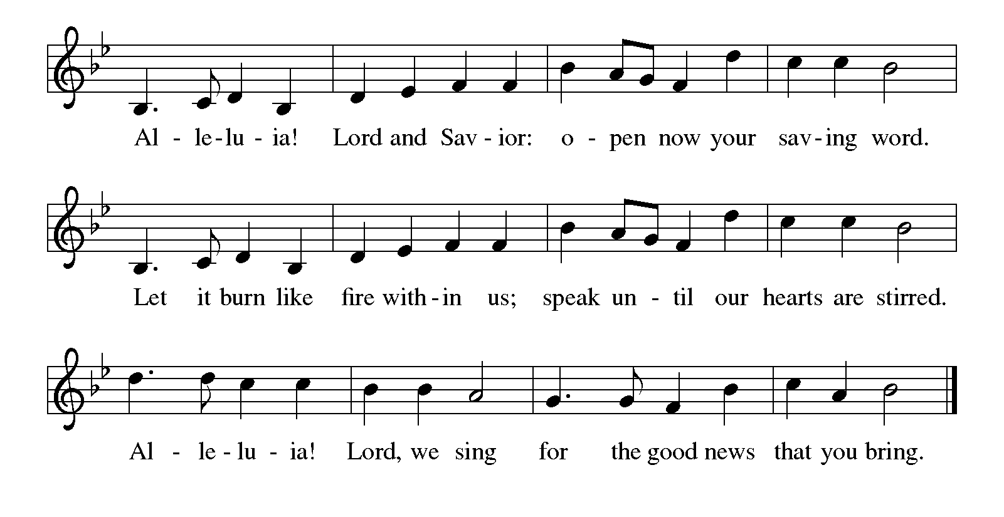

Gospel: Luke 6:17-26

After choosing his twelve apostles, Jesus teaches a crowd of followers about the nature and demands of discipleship. He begins his great sermon with surprising statements about who is truly blessed in the eyes of God.

Presider: The holy gospel according to Saint Luke:
All: Glory to you, O Lord.

Presider: ¹⁷[Jesus] came down with [the twelve] and stood on a level place, with a great crowd of his disciples and a great multitude of people from all Judea, Jerusalem, and the coast of Tyre and Sidon.¹⁸They had come to hear him and to be healed of their diseases; and those who were troubled with unclean spirits were cured. ¹⁹And all in the crowd were trying to touch him, for power came out from him and healed all of them.
²⁰Then he looked up at his disciples and said:
“Blessed are you who are poor,
for yours is the kingdom of God.
²¹“Blessed are you who are hungry now,
for you will be filled.
“Blessed are you who weep now,
for you will laugh.
²²“Blessed are you when people hate you, and when they exclude you, revile you, and defame you on account of the Son of Man. ²³Rejoice in that day and leap for joy, for surely your reward is great in heaven; for that is what their ancestors did to the prophets.
²⁴“But woe to you who are rich,
for you have received your consolation.
²⁵“Woe to you who are full now,
for you will be hungry.
“Woe to you who are laughing now,
for you will mourn and weep.
²⁶“Woe to you when all speak well of you, for that is what their
ancestors did to the false prophets.”

Presider: The gospel of the Lord.
All: Praise to you, O Christ.
The assembly is seated.

Sermon

The assembly stands.

HYMN of the day: Blest Are They (ELW Hymn 728) Verses 1-4

Creed

Presider: Let us confess our faith in the words of the Apostles’ Creed:
All: I believe in God, the Father almighty,
creator of heaven and earth.

All: I believe in Jesus Christ, God’s only Son, our Lord,
who was conceived by the Holy Spirit,
born of the virgin Mary,
suffered under Pontius Pilate,
was crucified, died, and was buried;
he descended to the dead.
On the third day he rose again;
he ascended into heaven,
he is seated at the right hand of the Father,
and he will come to judge the living and the dead.

All: I believe in the Holy Spirit,
the holy catholic church,
the communion of saints,
the forgiveness of sins,
the resurrection of the body,
and the life everlasting.
Amen.
Prayers of Intercession

Assistant: United as one body in Christ, let us pray for the church, the world, and all those in need.

A brief silence.

Assistant: We pray for the church. Raise up faithful leaders to proclaim the gospel. Guide us in the ways of love. Empower us in ministry and service, especially members of the Cotter, Hendersen, McDermott, Pozo and Valencia Families. Lord, in your mercy,
All: hear our prayer.

Assistant: For the nations. Grant wisdom to our elected leaders for the sake of the common good. Give courage to those who suffer persecution. Give patience and perseverance to those who work to bring an end to injustice. Lord, in your mercy,
All: hear our prayer.

Assistant: For those in need. For those who do not have enough food; for those who lack money; for those who are estranged from their families; for those who worry about many things. Comfort those who mourn. Heal and strengthen those who are sick, especially Otto, Hilda, Helen, Joseph, Jeanne, Irma, Christa, Mary, Belle, Jean, Angele, Joyce, Craig, Raymond, Florence, Donna, Christian, Virginia, Flora, Elizabeth, Horton, John and Elizabeth. Lord, in your mercy,
All: hear our prayer.

Assistant: For this assembly. For newcomers, visitors, longtime members, and those who are absent from us today. Root us deeply in your word and increase our faith. Lord, in your mercy,
All: hear our prayer.

Assistant: For the joyful. Let your glory be known in the midst of celebration. Bless those commemorating birthdays, especially Andrew, James, Lynn, Phyllis, Charles, Kate, Jean, Bennett, Nicholas, Calista, Jeanine, Ernie, Zara, Lori, Christa and Karin and wedding anniversaries, especially Amy and Richard. Lord, in your mercy,
All: hear our prayer.

Assistant: With thanksgiving, we remember those who have died, especially Brooke. Encourage us by their example and lead us in faith until we are united at your unending feast. Lord, in your mercy,
All: hear our prayer.

Presider: Receive our prayers and fill us with the radiance of your love; through Jesus Christ our Lord.
All: Amen.

Peace

Presider: The peace of Christ be with you always.
All: And also with you.

The people may greet one another with a sign of Christ’s peace, and may say, “Peace be with you,” or similar words.

The assembly is seated.
Meal - God feeds us with the presence of Jesus Christ.

Offering

An offering is gathered for the mission of the church, including the care of those in need. During this time, the table is set. The Offertory Anthem accompanies the gathering of the offering.

Offertory anthem: The Gift of Love (Hal Hopson)

The assembly stands. Bread, wine, money and other gifts may be brought forward.

PRESENTATION OF GIFTS and OFFERING SONG:
Let the Vineyards be Fruitful (ELW Hymn 184)
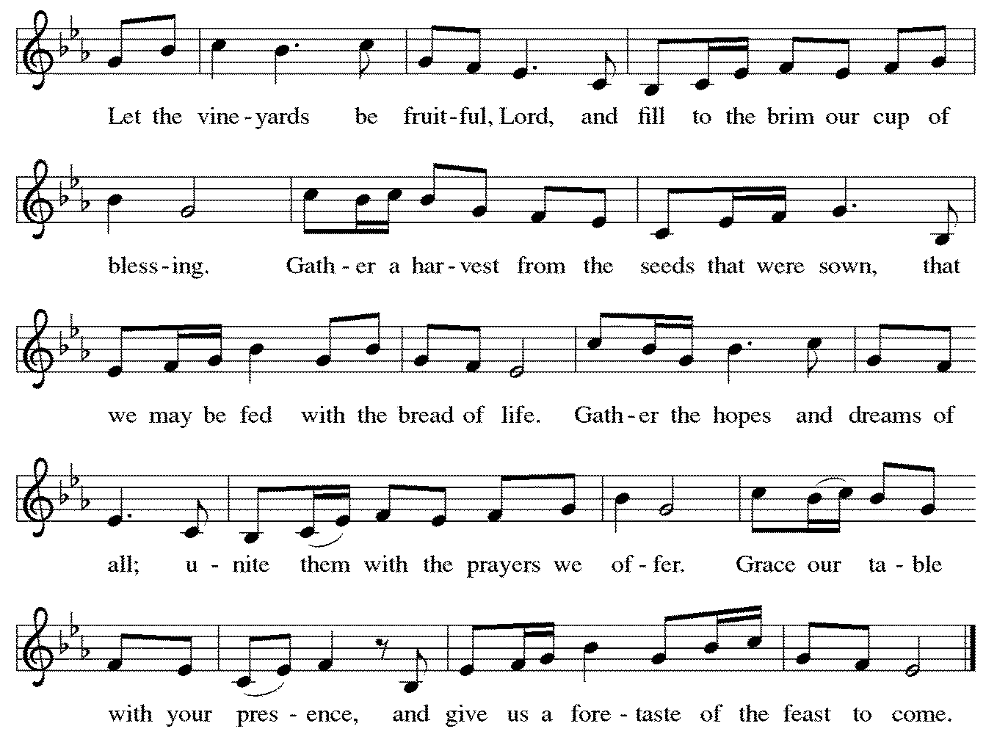

Offering Prayer

After the table is set, the assisting minister leads the following prayer.

Assistant: Let us pray.
God of all creation, all you have made is good, and your love endures forever. You bring forth bread from the earth and fruit from the vine. Nourish us with these gifts, that we might be for the world signs of your gracious presence in Jesus Christ, our Savior and Lord.
All: Amen.
Dialogue

Presider: The Lord be with you.
All: And also with you.

Presider: Lift up your hearts.
All: We lift them to the Lord.

Presider: Let us give thanks to the Lord our God.
All: It is right to give our thanks and praise.

Presider: It is indeed right, our duty and our joy, that we should at all times and in all places give thanks and praise to you, almighty and merciful God,
through our Savior Jesus Christ. By the leading of a star he was shown forth to all nations; in the waters of the Jordan you proclaimed him your beloved Son; and in the miracle of water turned to wine he revealed your glory. And so, with all the choirs of angels, with the church on earth and the hosts of heaven, we praise your name and join their unending hymn:
SANCtus: Holy, Holy, Holy

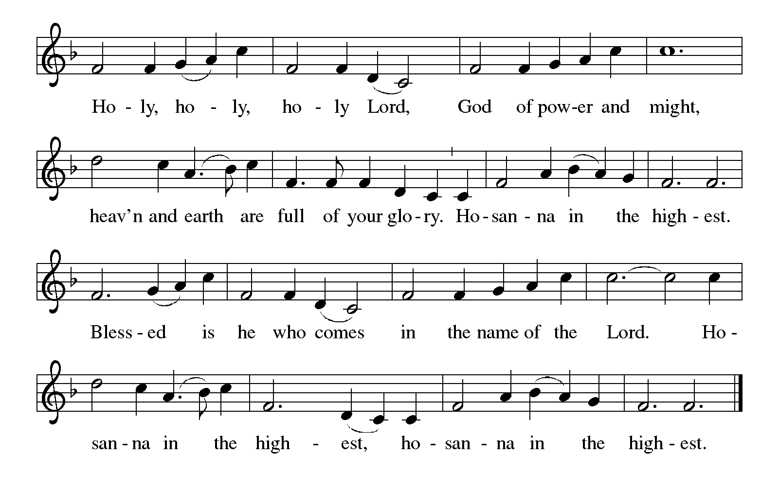
Thanksgiving at the Table

Presider: In the night in which he was betrayed, our Lord Jesus took bread, and gave thanks; broke it, and gave it to his disciples, saying: Take and eat; this is my body, given for you. Do this for the remembrance of me.

Presider: Again, after supper, he took the cup, gave thanks, and gave it for all to drink, saying: This cup is the new covenant in my blood, shed for you and for all people for the forgiveness of sin. Do this for the remembrance of me.

Lord's Prayer

Presider: Lord, remember us in your kingdom, and teach us to pray:
All: Our Father, who art in heaven,
hallowed be thy name,
thy kingdom come,
thy will be done,
on earth as it is in heaven.
Give us this day our daily bread;
and forgive us our trespasses,
as we forgive those
who trespass against us;
and lead us not into temptation,
but deliver us from evil.
For thine is the kingdom,
and the power, and the glory,
forever and ever.
Amen.

Invitation to Communion

Presider: Come to the table. Feast on God’s abundant life for you.

The assembly is seated. The bread may be broken for the communion.

Communion

We welcome all baptized believers, regardless of faith tradition, to celebrate Holy Communion at the Lord’s Table. Ushers will help guide all for the distribution of Holy Communion. Unless instructed otherwise, worshipers will approach the altar from the center aisle and, if able, kneel at the Altar Rail. The presiding minister will distribute the consecrated bread, or hosts. Assisting ministers will offer individual cups of consecrated red wine and white grape juice. Should anyone have dietary concerns, gluten-free consecrated hosts are readily available upon request to the presiding minister. If you do not wish to receive Holy Communion, you are still invited to come to the Lord’s Table to receive a blessing; kindly cross your arms as a method to advise the presiding minister of your desire to be blessed. When giving the bread and cup, the communion ministers say, “The body of Christ, given for you,” and “The blood of Christ, shed for you,” and each person may respond “Amen.” Following receipt of Holy Communion, the acolyte will collect the empty cups, and the communed worshipers are invited to return to their places via the side aisles.

Communion hymn
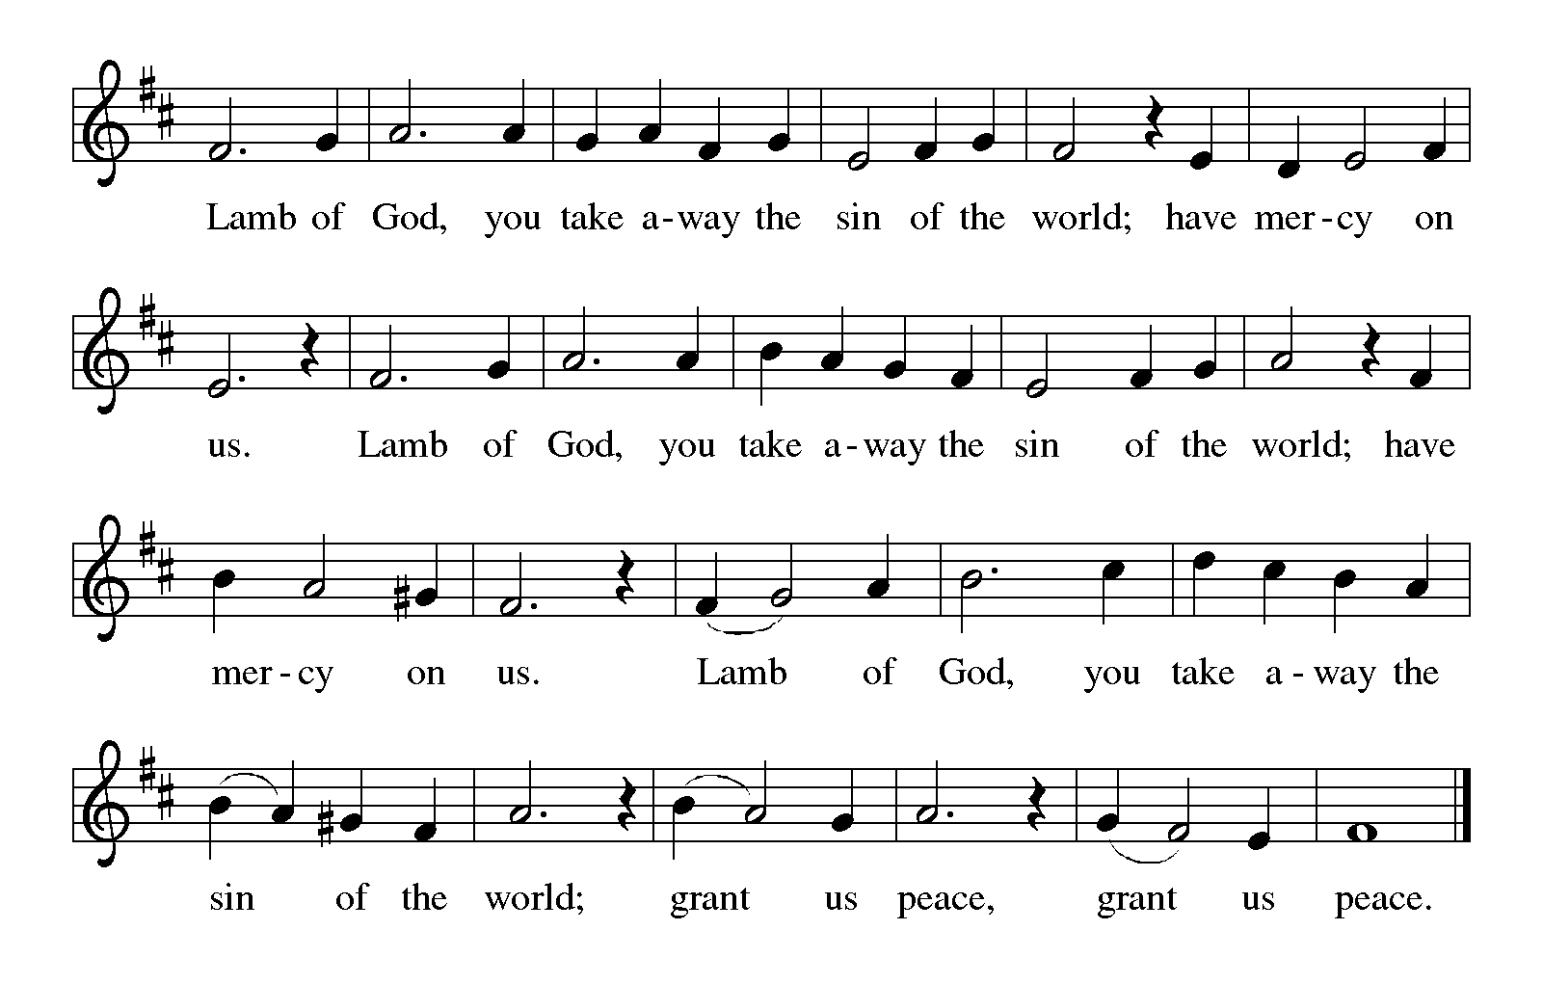
COMMUNION SONG: Amazing Grace (ELW Hymn 779)
Here I Am, Lord (ELW Hymn 574)
After all have returned to their places, the assembly stands.

table blessing

Presider: The body and blood of our Lord Jesus Christ strengthen you and keep you in his grace.
All: Amen.
POST-COMMUNION CANTICLE:
Thankful Hearts and Voices Raise (ELW Hymn 204)
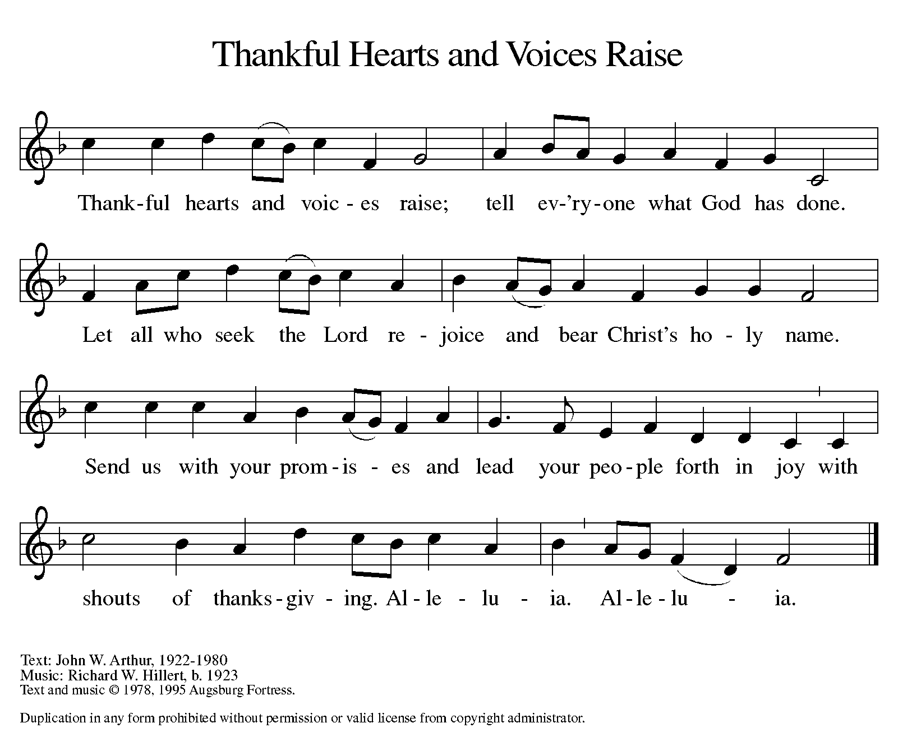

Prayer after Communion

Assistant: Let us pray.
We thank you, O God, that you have fed us at your banqueting table with bread and wine beyond compare, the very life of Christ for us. Send your Spirit with us now, that we may set the captive free, use your gifts to build one another up, and in everything reflect your glory revealed in Jesus Christ, our Savior and Lord.
All: Amen.

The assembly is seated.

Sending - God blesses us and sends us in mission to the world.

Announcements

Brief announcements may be made, especially those related to the assembly’s participation in God’s mission in the world.

The assembly stands.

BENEDICTION

Presider: The God of glory dwell in you richly, name you beloved, and shine brightly on your path; and the blessing of almighty God, the Father, the ☩ Son, and the Holy Spirit, be upon you and remain with you always.
All: Amen.

Sending hymn: God Bless Our Native Land (ELW Hymn 891)

Dismissal

Assistant: Go in peace. Serve the Lord.
All: Thanks be to God.

POSTLUDE: Prelude and Fugue in A Minor (J.S. Bach)

Copyright © 2019 Augsburg Fortress. All rights reserved. Reprinted by permission under Augsburg Fortress Liturgies Annual License #SAS000352.
New Revised Standard Version Bible, Copyright © 1989, Division of Christian Education of the National Council of the Churches of Christ in the United States of America. Used by permission. All rights reserved.
Revised Common Lectionary, Copyright © 1992 Consultation on Common Texts, admin Augsburg Fortress. Used by permission.

The Altar flower arrangement is from Alex and Wilma
in honor of their family.

Serving this Sunday, February 17th
Ministers: People of the Church of Our Saviour, Lutheran
Acolyte/Crucifer: Cathryn Weigand
Assisting Minister: Al Rainson
Lector: Lynda Walsh
Ushers: Harold Feldhusen & Erwin Schaub
Altar guild: Louise Benes & Carol Furciato
Recorder: Karen Han
Coffee Hour: Open

Serving next Sunday, February 24th
Ministers: People of the Church of Our Saviour, Lutheran
Acolyte/Crucifer: Flora Meredith
Assisting Minister: Liana Bordonaro
Lector: Adrienne Nagy
Ushers: Dan Nigro & Alex Rekow
Altar guild: Adrienne Nagy & Janice Pupelis
Recorder: Kathy McNally
Coffee Hour: Sieglinde Lubbers

THIS WEEK AT THE CHURCH OF OUR SAVIOUR, LUTHERAN (COSL)

Today, Sunday, February 17th
10:00AM—Worship with Holy Communion, Sunday school, Childcare
11:30AM – “Spring Fiesta” planning meeting
Monday, February 18th
Presidents’ Day – Church office is closed.
Tuesday, February 19th
10:00AM – Ruth Circle crafts/Knitwits

UPCOMING CHURCH EVENTS

SUNDAY SCHOOL: Class meets most Sundays @ 10:15am from September through June.

KNITWITS/RUTH CIRCLE CRAFTS: This group meets most Tuesdays at 10am.

COUNCIL MEETING: The Council’s next meeting will take place on Tuesday, February 26th @ 7:30pm.

STAMMTISCH MEETINGS: This group’s next meeting will be Tuesday, February 26 @ 1pm.

RUTH CIRCLE BABY SHOWER: This annual event will take place on Sunday, March 3rd following worship @ 11:30am. Snow date is Sunday, March 10th @ 11:30am.

UPCOMING CHURCH EVENTS (cont’d)

ASH WEDNESDAY SERVICES: Services will be held at noon and 7pm on Wednesday, March 6th.

CONFIRMATION CLASSES: Confirmation classes in March will meet on the following Wednesdays @ 6:15pm: March 6th, 13th, 20th and 27th. A detailed list of all classes was issued to all Confirmation families.

RESOURCE COMMITTEE MEETING: This meeting will take place following worship on Sunday, March 10th @ 11:45am.

COUNCIL MEETING: The Council will hold its March meeting on Tuesday, March 19th @ 7:30pm.

FIESTA NIGHT: This fundraiser will be taking place on Saturday, March 30th @ 6pm. See flyers in parlor and bulletin board for more information.

2019 ALTAR FLOWER CHART

A 2019 altar flower chart is up on the bulletin board to sign up for your Sunday altar flowers. There are still plenty of dates available. Cost is $25.

PRAYERS OF COMFORT AND HEALING
(Unless a renewed request is received, prayer intercessions for individuals will be listed for three consecutive weeks.)

ASSISTED CARE/HOMEBOUND: Otto Ackerman, Hilda Bormann, Helen Carstens (mother of Jeff Carstens), Joseph Cobb (father of Carol Herbst), Jeanne Geib, Irma Grunewald, Christa Horn, Mary Kavanagh, Belle Lewis, Jean Millington (mother of Debbie Capilupi), Angele Moomjy and Joyce Morin.

HOSPITALIZATION/ILLNESS/MEDICAL CARE: Craig Anderson (father of Keri Anderson Reda), Raymond Bordonaro (father in law of Kristine Bordonaro), Florence Buzzitta, Donna Houman (friend of Elise Cueto), Virginia Marshall, Flora Meredith, Christian Miller (son of Katie Miller), Elizabeth Nagy, Horton Schwartz (brother of Jeanine Levitan), John Stallard (friend of Denise Johnson) and Elizabeth (Betty) Kelly Volker (mother of Eugenia Kelly Viner)

GRIEF: Family of Brooke Pearson (friend of Flora Meredith)

PRAYERS OF THANKSGIVING—2/17-2/23
BIRTHDAYS: Andrew Giordano, James Morakis, Lynn Nigro – 2/17, Charles Navas, Phyllis McDermott, Kate Petras – 2/18, Jean Cogan, Calista DiSapio, Bennett & Nicholas Gulbenkian, Jeanine Levitan – 2/20, Ernie Aiello and Zara Zung – 2/21, Lori Quinn – 2/22, Christa Horn and Karin Stainkamp – 2/23

ANNIVERSARIES: Amy and Richard Freund – 2/18

FINANCIALS
JANUARY YTD

Income: $20,307
Expenses: $30,337
Deficit: $(10,030)

2019 SACRIFICE AND SERVE LENTEN SERIES

Each week during our worship in the Lenten Season a special guest will exemplify the Lenten call to “Sacrifice and Serve.” We will learn of those caring for others, and lift them up in prayer for their service, and be inspired to consider personal opportunities to serve God in similar means of thanksgiving.

March 10th: Hunger & Poverty
Jean Kelly, The Interfaith Nutrition Network
March 17th: Emergency Response
Neela Mukherjee Lockel, American Red Cross
March 24th: Labor/Workforce
John Durso, Long Island Federation of Labor
March 31st: Public Service
Honorable Thomas Suozzi, U.S. Congressman
April 7th: Addictions
Drew Scott, Opioid Addiction Task Forces

MIDWEEK LENTEN WORSHIP: Each week, on Wednesday evenings, beginning at 7:00 PM, you are invited to join us for a brief, approximate 30-minute, worship service.

March 13th: Luke 4:1-11
March 20th Luke 13:31-35
March 27th: Luke 13:1-9
April 3rd: Luke 15:1-3, 11b-32
April 10th: John 12 1-8
April 17th: Seder (Passover 4/19-27)

